Log Book, Group Project Assignment, Part A

25th January 2019: Group Meeting

Discussed each member’s work with following aspects of assignment:

Persona – Mary’s most in-depth

These are some of Mary’s designs which were used as the discussion points for amendments, changes

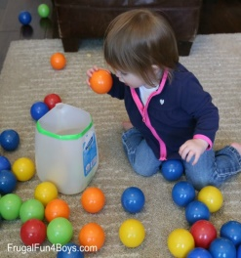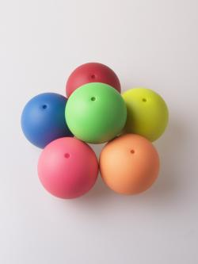

**Bag it!**

***Goal:***

Complete sequence to light exercise sash lights.

***How:***

Put on exercise sash with sensors and each arm band with sensors. These will detect movements to recognize when correct motion taken.

Drop virtual ball in screen mimicking image directions into virtual bag. May be done while seated or standing.

Virtual image shows which hand to use and whether the hand is lifted in front of body or to side to drop ball into virtual bag. Bag only appears when it is to be used.

***Success***:

Virtual exercise game keeps track and will note ‘success’ once sequences completed resulting in sash lights coming on and flashing.

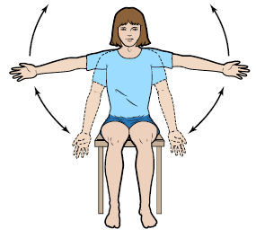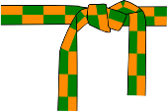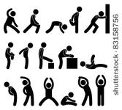

Use of Building – Gordon and Sam explained UK ‘smart home’ concept

Energy – Different views as to what this was

Chose majority view – ‘smart home’ utility ‘energy’ over exercise ‘energy’

Exercise graphic – view agreed that this needed to be more ‘block image’ with only one main image, less clutter

Mock-up of pills – Gordon’s previous work in psychology and with adults with autism helped define this – a pill image, not an outside container

Break-up of work – Sam to work on storyboard, Gordon and Mary to do research, persona, logbook, and critique Sam’s efforts

Designing for classic iPad – use Portrait

Graphical elements – make buttons obvious for pressing, not separate ‘enter’ button

Home Page – make these 3-d buttons

Energy – Floor plan – Map assign plus an Access Page

Change Pills display to provide lower level screen with more information

29th January 2019: Sam and Gordon met as Mary was at a meeting off-campus

Changes to Interface to incorporate lecture details

31st January 2019: Group Meeting

Sam did a walk-through of Interaction Design with Mary

Gordon and Mary offered additional suggestions, Sam still had some work he planned but had not yet implemented

Discussion was about robot – what did it look like, could Interaction Panel show robot had received request/was moving to comply/had returned with item and how user could confirm

Confusion that Sam and Gordon had not seen Vision announcement of presentation times – but Mary had from day before

Did the research show that design made use of personal experience as well as readings?

Decision which member would do what part in presentation

Confirmation that Tuesday Group Meeting would be reserved for Interaction Design project work through remainder of term – Mary to book for group

1st February 2019: Feedback notes from Presentation

Energy Displays: Need motivation for interaction. Currently not showing actual usage which can provide motivation.

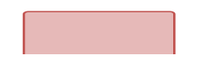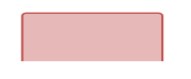

Energy



Ground Floor



1st Floor

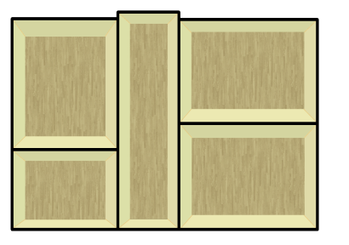

Bedroom

Kitchen

Sitting Room

Bathroom

Hall



**10:57 am**



Edit

Exercises: Need motivation to engage in exercise. Thought: add social element.

Other motivational options?

Medicine Display: No indication when missed dosage.

Personas: Build existing personas so that more than just one generic one.



Smart Assistant



Settings

**10:57 am**

5th February 2019: Group Meeting

Redesign of Energy Display to take into account Feedback:

Remove Floor Design – replace with bar charts to show day’s usage covering one week

Energy pop-up tips on main Energy page

Addition of Exercise Buddy to Exercise screens – Instructor, Image for you, and Image for Buddy – discussed but decided against

Add a button at the start of the ‘Add Exercises’ screen so user can suggest exercises

Exercises give feedback as to how well user is performing the exercise

Add Bowling, Add Golf – to give ‘pleasurable’ exercise to motivate.

Warnings on any of Main Menu Items makes button flash

Change to medicine selection – add tick mark

Report sections divided between group members, aim for 500 – 600 words each:

Sam will do GUI Design Layout

Gordon will do Medicine content

Mary will do Exercise content

Aim to have each report sections written for next Tuesday’s group meeting

Sam is uploading his version of a report template to GitHub for all to use with the aim of making report look similar

8th February 2019: Lab Visit to Assisted Living Facilities, Lyell Centre, introduction to Cozmo robot Bob

Class visited Assisted Living facilities, given first introduction to Cozmo robot and options for our interaction with and programming of

Group members were able to connect with robot, use the Sandbox application to give robot instructions, like ‘find block’, ‘lift block’, ‘move one step back’, and see that these were performed

This suggested how the interactions between robot and our designed interaction panel might require changes

Group members agreed that our aim is to use the Development Kit initially for our programming; then if we achieve programming for the planned interaction device, we may move on to Python coding to provide same

Group members took our assigned Cozmo robot Bob for two hours to familiarize our devices with connecting to it and to set up the Development Kit for programming Bob

Mary did not have a mobile device with her, so connecting with Cozmo will be during next lab access on Friday

Gordon noted that we could look for ways to add emotion in Bob as people enjoy interacting with a robot who shows some ‘human’ emotion

12th February 2019: Group Meeting, Sam is absent due to illness

Gordon has uploaded some example code for Cozmo programming; this will help Mary whose android tablet will probably be unable to link to Cozmo.

Gordon and Mary agreed that we should look at writing Python code for Cozmo responses. It was also agreed that we should investigate how/whether we could create the necessary GUI for Cozmo’s interaction.

For report, it needs rejigging – instead of initial and amended content sections, just explain what the content is, research to support that design decision.

Given 5 ½ hours on Thursday for robot programming, neither Gordon nor Mary can free themselves for the full time. So we will attempt to use 2 hours when we don’t have classes to test out Python programming that we hope to code before the Thursday session.